On the Road – Job exchange from Denmark to Qatar

From October through December 2014, engineer Paw Nielsen from the Danish NRA worked in Qatar as a part of the CEDR exchange program. An experience that developed Paw both professional as well as personally. And, he discovered, the desert state is actually short of sand.

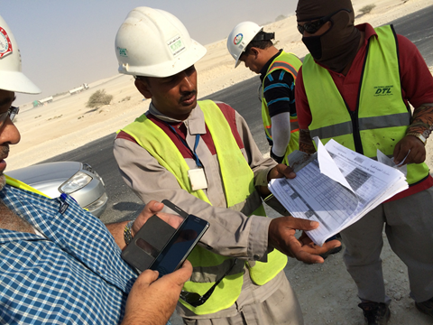
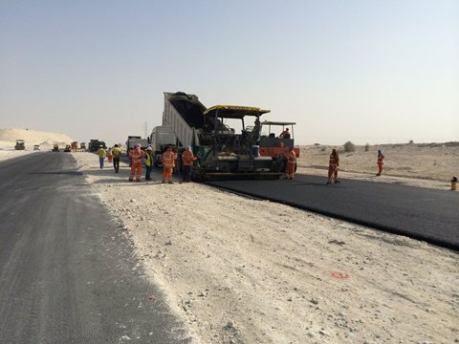

The NRA in Qatar needed a system, that would ensure the best possible quality in their road projects, and The Italian NRA, ANAS, had been contracted to develop the system. As part of the CEDR exchange program, Paw became a part of the project and during his time in Qatar, he participated in developing a system, meant to control everything from quarries, gravel pits, asphalt plants and laboratories for laying and compression of road surfacing.

In Paws opinion, one of the most significant differences between working in Qatar compared to Denmark is the workforce.

“In Qatar, all work is carried out by workers who concentrate only on one specific task. The man, who tightens the wire, that runs the machine, only tightens that wire and does not take responsibility for anything else in the process. That way, the general overview of the project is very narrow and as a result of that, each specific task involves many more workers than in Denmark.”

“Also” Paw say “the materials used in Qatar are significantly different compared to Denmark. Contrary to what you may think, sand is not a building material, which is easy to come by in Qatar. Of course there is loads of sand, but not the special kind, that is able to support the kind of carrying capacity, which is needed for roads. So, opposite to the old saying you do not need an extraordinary sales talent for sell sand in a desert.”

Enormous professional outcome
During Paws time in Qatar, he followed the process from the final road design to the point where the road is ready for use.

“The professional outcome has been enormous for me. In spite of, that the work culture is very different from the Danish, there are also many similarities and I have gained a much wider knowledge on how to perform the different lab-tests and where the most common sources of errors are” Paw says.

“Moreover, I have learned that I am not made for traffic jams. Traffic in Qatar is really challenging and the distance from my hotel, which was 8 kilometers, could last anything from 30 minutes up to as long as three hours. No matter when or where you are going in Qatar, you have to expect to be jammed up in traffic.”

“It has been a great experience for me and I will definitely encourage others to try job-exchange if they have the opportunity. It has been very interesting to experience another culture and, for a short while, become a part of it” Paw finishes.

