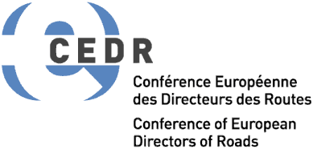

Qualities of a successful CEDR exchange programme candidate
A successful candidate possesses the following qualities (in alphabetical order):

1. Committed
A successful candidate is committed to the given field (s)he is required to work in; therefore (s)he is eager and enthusiastic about working on the tasks or projects given to him/her.

2. Competent
A successful candidate is competent in the given field and has sufficient skills and experience.

3. Confident
A successful candidate is self-confident; participating in an exchange programme requires someone who is decisive and sure of themselves.
4. Flexible
A successful candidate is able to adjust to the new circumstances, environment and principles, and to the culture of the receiving country; (s)he is ready to accept change and behaves accordingly.

5. Good communicator and team player
A successful candidate is able to communicate in a clear and effective way, works well together with others, and is pleasant to work with.

6. Hard-working
A successful candidate is high performing. (S)he applies a sufficient level of effort to perform his/her duties, (s)he thrives at work, and looks for more work if everything assigned to him is done.

7. Modest
A successful candidate does not boast about his/her accomplishments but prove his/her value through hard and commendable work.

8. Openness
A successful candidate is always ready and eager to acquire and share new knowledge, skills, methods, etc. that can be beneficial for the candidate and for both the sending and receiving companies.
9. Proactive and creative
A successful candidate is not afraid of taking initiative in discovering inventive methods of being productive so that the company(-ies) may gain from it in the process. A successful candidate has his/her own constructive ideas that promote development.

10. Reliable and honest
A successful candidate can be trusted to deliver on his/her promises, meet deadlines and take his/her responsibilities seriously. (S)he is always fair and forthright.

