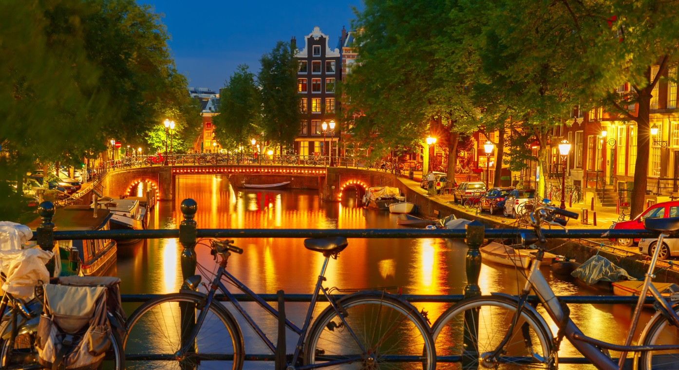
Welcome to the Netherlands

Government: Constitutional monarchy/ Parliamentary democracy. Dutch monarch has no real political power, but serves as representative head of state and a symbolic person uniting the divided parliamentary politics.
Capital: Amsterdam
Official language: Dutch
Area: 41.543 km²
Population: 17 055 000
Currency: Euro (EUR)

History at a glance:
The Netherlands has an interesting historical background with lots of experiences from long years of wars and battles between nations, division of land regions and colonies, and inhabiting tribes from different parts of Europe, throughout the world even. It all started when Julius Caesar found the Netherlands which was then inhabited by Nervii, Frisii and Batavi tribes who are of German origin. After a number of years, the Franks invaded the country during the 4th century until the 8th century, and by Charlemagne from the 8th to the 9th century. After almost 7 centuries, the Spanish invaded and conquered the Netherlands and influenced the country by spreading Christianity.
In 1568, people of the Netherlands revolted against the Spanish rule lead by William of Orange. This is because King Phillip II suppressed the people’s political liberties which led to the people building their own Protestant movement. In 1579, the 7 northern provinces of the Netherlands formed their own union named United Provinces of Netherlands. After almost a hundred years of colonization, Spain granted independence to the Dutch in the year 1648.
During the Thirty Years War from 1618 to 1648, the Netherlands gained maritime power because of its strategic geographical location. Moreover, it has gained commercial influence in Europe and its colonies.
By 1814, all provinces of the Netherlands merged with Belgium and formed one Kingdom. After over 15 years, the southern provinces of the said kingdom formed the Kingdom of Belgium.

In 1940, the Nazis invaded the Netherlands and 5 years after, the nation was liberated. The Netherlands then joined the European Economic Community (now the European Union) in 1958.
At present, Netherlands is known for being the first nation to legalize euthanasia and same-sex marriage.

Geography, demography and roads:
The Netherlands is located in North Western Europe, at the West and North-West coastline the North Sea; the country borders with Belgium from the South and Germany from the East and Northeast. Through its long North Sea coast (451 km) the climate of the Netherlands is a typical mild maritime climate, wet and mild, winters are rarely strong, summer is never very hot.

With 139,000 km of public roads, the Netherlands has one of the most dense road networks in the world. Dutch roads include at least 3,530 km of motorways and expressways. The Netherlands' main highway net (hoofdwegennet), comparable to Britains net of trunk roads, consists of most of its 5,200 km of national roads, supplemented with the most prominent provincial roads. Although only about 2,500 km of roads are fully constructed to motorway standards, much of the remainder are also expressways for fast motor vehicles only.

Except for motorways and expressways, most roads support cyclists. Some 35,000 km (a quarter of all Dutch roads) feature dedicated cycle tracks, physically segregated from motor traffic. A further 4,700 km of roads have clearly marked bike lanes, and on other roads, traffic is calmed such that cyclists and motorists can safely mix. Busy junctions sometimes give priority to cyclists, and in street roads like ‘fietsstraten’ and ‘woonerven’, bicycles always have priority over cars.

Everyday life
Most shops are opened every day from around 9 a.m. until 5.30 p.m. On Monday mornings, shops often don’t open until around noon. Most towns and cities have a shopping night when shops are opened until 9 p.m. This is usually on a Thursday.
Every Dutch city has its own rules for shopping on Sundays. Dates are available at the local tourist information (VVV). In most big cities, supermarkets are open every day until 10 p.m., except on Sunday’s when they close around 5.30 p.m. In other parts of the country, supermarkets are usually opened until 8 p.m. on weekdays and Saturdays, with varying opening times on Sundays.

Most banks and post offices are open from Monday to Friday between 9 a.m. and 5 p.m. Only major banks and post offices are open on Saturday. GWK Travelex is open every day of the week. Most GWK Travelex offices are located nearby train and bus stations.

The Dutch don’t have a specific cuisine. You can find a regular meal of potatoes, vegetables and meat just as easily as a proper Indian, Chinese, Surinam, Turkish, Italian or Mediterranean meal. We simply like everything.
Breakfast and lunch are simple meals of bread, fruit and dairy products. Supper is usually a warm meal between 6 and 7 o’clock. Keep in mind that most kitchens in restaurants tend to close between 10 and 11 o’clock.

The Netherlands has an excellent public transport system. Wherever you want to go in the Netherlands, the bus, train, metro or ferry will probably get you there. Furthermore, there are frequent services and all means of public transport are perfectly safe - and affordable. If you want to use the public transport system in Holland, you will need an OV chip card to pay for your trip. These are available from railway and bus stations and at the bigger supermarkets. All you need to do is charge credit to the card and you can use it immediately.

Social ways
The Dutch are creative, open minded and pragmatic. They are also rather direct, honest and open in their dealings with others.

Fun facts about the Netherlands:

- "The Netherlands" and "Holland" are used to describe the same country?
- One quarter of the Netherlands is below sea level?
- The Netherlands has approximately 480 inhabitants per square kilometre?
- The Netherlands was one of the European Union's founding nations?
- The Netherlands has at least 15,000 km of bicycle paths?
- Dutch is also spoken in Belgium, northern France, Suriname, the Netherlands Antilles and Aruba?
- The Netherlands still has about 1,000 traditional working windmills?
- The Dutch are the tallest people in Europe?
- Amsterdam is entirely built on piles?
- The Netherlands always has a coalition government, which makes it a country of compromises?
- The Netherlands has nearly 1,000 museums, with 42 in Amsterdam alone?
- Almost every Dutch person has a bicycle and there are twice as many bikes as cars?
- The Netherlands is the world's eighth largest exporter?
- People in Holland eat raw herring with onions on top?
- About 30% of all Dutch babies are born at home?
- The Netherlands has the highest number of part-time workers in the EU (four in ten people)?
- The Netherlands' highest point is 323 metres high and is therefore called a "mountain"?
- You'll find a bunch of flowers in almost every Dutch living room?
- Amsterdam is the capital of the Netherlands, but The Hague is the seat of government?
- Most Dutch people speak at least one foreign language?
- After Scandinavians, the Dutch are the world's biggest coffee drinkers?
- When your plane arrives at Schiphol, it lands 4.5 metres below sea level?
- The Netherlands has the highest cable density in Europe?
- Amsterdam has 1,281 bridges?

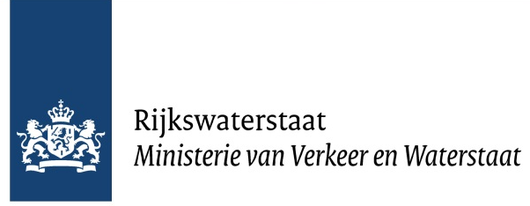

Rijkswaterstaat

Rijkswaterstaat was founded in 1798 as the Bureau voor den Waterstaat, and is part of the Dutch Ministry of Infrastructure and the Environment, the former Ministry of Transport, Public Works and Water Management. Rijkswaterstaat is responsible for the design, construction, management and maintenance of the main infrastructure facilities in the Netherlands. This includes the main road network, the main waterway network and watersystems.
- Highways: The Dutch mobility policy serves 2 goals: reliable journey times and better accessibility. By 2020, motorists travelling in the rush hour must be able to arrive punctually 95%of the time, despite increased mobility and unexpected congestion. The Dutch economy relies heavily on transport and logistics, the main economic centres must remain accessible.
- Waterways: Smooth and safe transport by water are other ways of using water. The Dutch waterway network is the densest in Europe. About 6000 kilometers of rivers and canals, many of the latter serving drainage as well as navigation, form a complex system serving all parts of the country.
- Water systems: Dry feet, sufficient clean water and reliable and useful information. That is what integrated water management means to Rijkswaterstaat. All measures are planned around the users, nature and the landscape and are carried out in close cooperation with water boards, other public authorities, NGOs and private parties.

Rijkswaterstaat is dedicated to promoting safety, mobility and the quality of life in the Netherlands. We want to live in a country that is protected against flooding, where there is sufficient green space and an adequate supply of clean water and where we can travel quickly and safely from A to B.

The agency is divided in 7 national and 7 regional services, totalling around 8700 employees.

