Welcome to Denmark
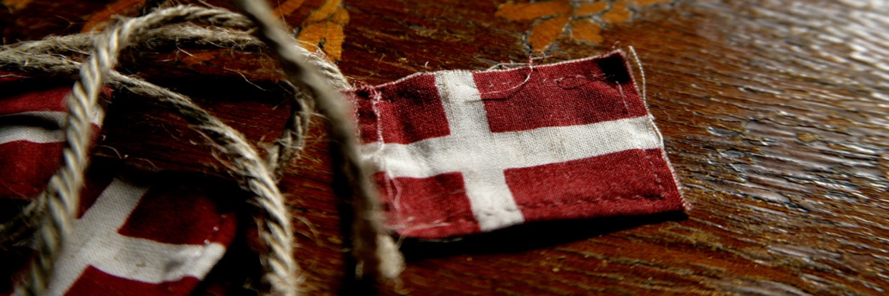

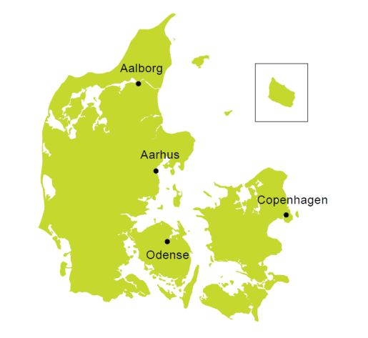
Facts

Name: Kongeriget Danmark - The Kingdom of Denmark
Form of government: Constitutional monarchy with parliamentary democracy.
Area: 42,916 square kilometres
Population: 5.6m inhabitants
Average life expectancy: Men 78.0 years, women 81.9 years
Capital: København (Copenhagen), 1.246.611 inhabitants in the metropolitan area
Major cities: Aarhus 259.754, Odense 172.512, Aalborg 109.092
Language: The official language is Danish. English is widely spoken
Religion: 78 % belong to the National Lutheran Church
Currency: Danish krone (DKK)
National flag: The National flag of Denmark, Dannebrog is red with a white cross that extends to the edges of the flag. Dannebrog is the oldest flag in the world still in use by an independent nation. According to the legend, Dannebrog was a gift from God and fell from the sky during a battle in Estonia securing Danish victory

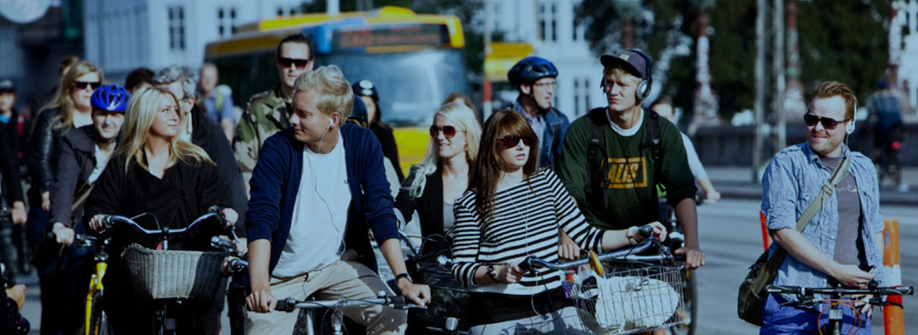

History at a glance - and a country with no mountains
Denmark is a small Scandinavian country in northern Europe. Denmark has been a kingdom since approx. 900 AD and has since 1849 been a constitutional monarchy. The Kingdom of Denmark also comprises the Faroe Islands and Greenland; nations that today enjoy extensive home rule and have their own parliaments, culture and language. The official language in Denmark is Danish but English is widely spoken.

Denmark is Viking country, full of opportunities for Viking adventures of your own. It's also a place where you can explore the impressive legacy of fairy-tale writer Hans Christian Andersen. Denmark is full of castles, manor houses and formal gardens. Get up close to Danish royalty of the past and present at famous castles such as Kronborg and Egeskov. You can visit the homes of Crown Princess Mary and Crown Prince Frederik and Queen Margrethe. Or stay in a castle yourself!

Denmark has an average height of 31 meters, and the Norwegian writer Roger Pihl argues that in that perspective, every hill with a height above 100 meters should be considered a Danish bjerg [b-yaᵒᵒ] (mountain).

Everyday life

In Denmark you will find that the distances are short, and this makes it possible to combine the atmosphere of a buzzing city life with the relaxation of the beautiful Danish country- and seaside. Clean beaches and green forests are rarely more than a half hour’s drive away.

Denmark's high taxation rates stem from the emphasis placed on work-life balance, democracy and other areas people prioritize. This gives rise to a welfare society that runs smoothly in many respects. The high level of social welfare contributes to a society that is accustomed to generally high standards with free education, health care, etc. The employee demand for flexible work hours is due to the fact that the majority of both men and women work.
It's easy to get around Denmark by public transport. Distances between places are small, so you can get from one end of the country to the other relatively quickly. Public transport Denmark is in good shape, but there are variations from city to city. In general, the further away you get from major cities, the more normal it is to rely on private cars for transportation.

In Denmark, more than 30% of electricity is generated by wind power. Denmark is known for its high level of energy efficiency and its sustainable, freewheeling bicycle culture.

There are very few foods that are truly Danish in style – but you might find yourself being offered “frikadeller” (meatballs) or “marinerede sild med snaps” (pickled herring with a small shot of a strong alcoholic beverage). At Christmas time the Danes often spend time with the nearest family, indulging in specific food traditions for example “flæskesteg” (pork roast) or roasted duck served with “brune kartofler” (potatoes fried in butter and sugar). Breakfast and lunch are usually simple meals of bread, fruit and dairy products, while dinner is usually a family affair, taking place not too late in the evening.

Social ways

What could be more inspiring than living in the happiest country in the world? The Danes are consistently surveyed as being the ‘world’s happiest people’. Denmark is a welfare state known for its quality of life, social cohesion and high regard of social liberties. Denmark is a wealthy and safe country and the Danes enjoy a good work-life balance and a high level of income equality.

The Danes are known for their easygoing lifestyle, but can also be seen as a bit reserved. In the typical Danish workplace, everyone is encouraged to contribute with ideas and professional opinions regardless of title or status. Moreover, everyone relevant is always involved in making decisions.

This means that the general atmosphere in a Danish workplace is professional, but also casual and informal. Many workplaces have what resembles a flat management hierarchy, which means it is more than normal to take up issues directly with the CEO.

Danes hold many meetings to facilitate the free flow of communication and secure unity, common understanding and consensus in the workforce. In addition to this, Danes believe in informal knowledge sharing. This means Danes eat lunch together and hold coffee breaks during the day to socialize and discuss both private and work related topics.

Fun facts about Denmark

- Danes really like pickled herring.
- Danes enjoy salty licorice with a cold glass of milk.
- Danes have a strong sense of irony.
- The UN World Happiness Report has rated Danes as the happiest people on earth two years in a row.
- Danes have a special word "hygge" for that cozy feeling of togetherness. It means relaxing in great company.
- Danish pastry is actually called "wienerbrød" or "Viennese bread" in Denmark.
- The Danish language has no word for "please".
- When crossing the road Danes typically wait for the traffic signals to change to "go". Even if the road is clear!
- First acknowledged in 1219, the Danish flag remains the oldest state flag in the world still in use by an independent nation.
- Danes eat an average of 42 sausages a year.
- LEGO is actually Danish!
- With no mountains in Denmark, biking is never uphill!
- 50% of Copenhageners commute to work every day on bicycle - come rain, come shine.
- Denmark doesn't have bike lanes, they have special elevated roads for bicycles!
- Copenhagen has more Michelin-starred restaurants than any other city in Scandinavia
- The Copenhagen harbor is clean enough to swim in!

The Danish Road Directorate (Vejdirektoratet)

The Danish National Road Administration (NRA), called Vejdirektoratet, is responsible for the state-owned roads in Denmark. We promote an integrated road and transport system. With special consideration to the environment, we are working towards a safe, secure and easy journey on the roads for people as well as for goods.
